# File permissions in Linux

## Project description

In this project I had to view permissions employees had to various directories/files and update them using Linux commands.

The decision was simply based on employee duties and what department they worked in.

## Check file and directory details

To check the permissions of a directory/file I use the command ‘ls -l’ if I just want to see visible directories/files. However, if I want to see permissions for hidden files I run the command ‘ls -la’.

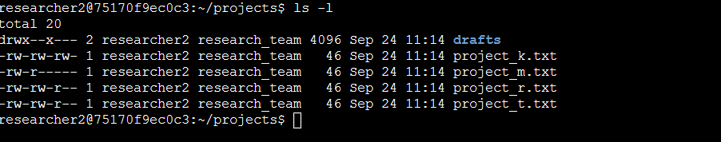

## Describe the permissions string

The permission string contains 10 characters, with the first character being ’**d**’ which stands for directory or a hyphen ‘**-**’ which indicates it’s a file.

There are 9 characters left in the string, with each character giving users different privileges, for example ‘**R**’ to read files, ‘**W**’ to modify contents in a file/or add a new subdirectory to an existing directory, and ‘**X**’ to execute a program in a directory.

If we wanted to give the user permission to read and write, I would run the command ‘chmod u+rw employees.txt’ to grant this.

Lastly, there are 3 types of users when it comes to the file system hierarchy, with the first being the user, second a group, and lastly others within a system.

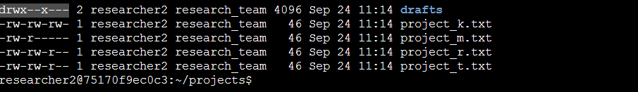

## Change file permissions

To remove others in the system from executing a program in a file, I run the command **‘**chmod o-x employees.txt’.

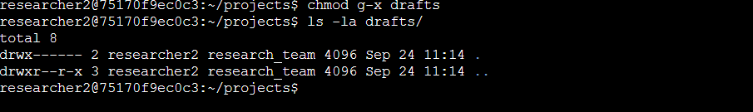

## Change file permissions on a hidden file

To do this I would run **‘**chmod u-wx ‘.payroll.txt’, to allow the user to only be able to read information on payroll such as the HR department.

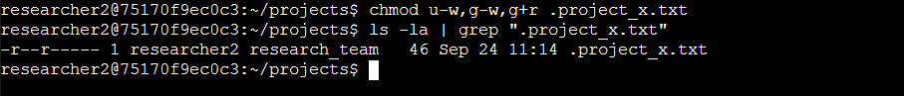

## Change directory permissions

‘Chmod u+r Important’, this would allow users to read the contents of this folder.



## Summary

I have learnt how to view permissions for all users in a system, and update this using Linux commands within the terminal.

This is super helpful as I can strengthen an organization's security by following the principle of least privilege, by analyzing data quickly and making adjustments where necessary.